Pg. 155 - 161, Java Programming *A comprehensive Introduction*

Arrays

**Due Wednesday 4/2/14 during lab**

**Section 1: Define / Answer**

Array: An array is a container object that holds a fixed number of values of a single type.

Primitive Data Type Variables: A variable of a non-primitive type doesn't contain the value directly; instead, it is a reference (similar to a pointer) to an object. (It is not possible in Java to create user-defined value types). Java has eight primitive types: byte , short , int , long , char , boolean , float and double .

One-Dimensional Arrays: One dimensional array stores numbers in one direction (horizontal only) eg imagine an array called 'array' with the following values

Type [] array-name = new type[size]: The way to create a array;

Array Element: an array data structure or simply an array is a data structure consisting of a collection of elements (values or variables), each identified by at least one array index or key.

Array *Index:* Array indexing refers to any use of the square brackets ([]) to index array values.

How is 0 used? Because 0 is how far from the pointer to the head of the array to the array's first element.

Array Initializers? Type [] array-name = new type[size]

|  |  |  |  |  |
| --- | --- | --- | --- | --- |
| 1st Position  For Data | 2nd Position  For Data | 3rd Position  For Data | 4th Position  For Data | 5th Position  For Data |
| 0 | 1 | 2 | 3 | 4 |

**Programming Assignment**

Pg. 201, Java Programming *A comprehensive Introduction*

Task 1- Page 201 # 1:

Show two ways to declare a one-dimensional array of 12 doubles.

{1.0, 2.0, 3.0, 4.0, 5.0, 6.0,7.0, 8.0, 9.0, 10.0, 11.0, 12.0};

For the first example print the 7.0 and 10.0 in a println.

Example - Your println should match

7.0

10.0

For the first example print the 2.0 and 12.0 in a println.

Example - Your println should match

2.0

12.0

Attach a 2 different snipping photos. The Snipping photos should include the programmer source code and the outputs.

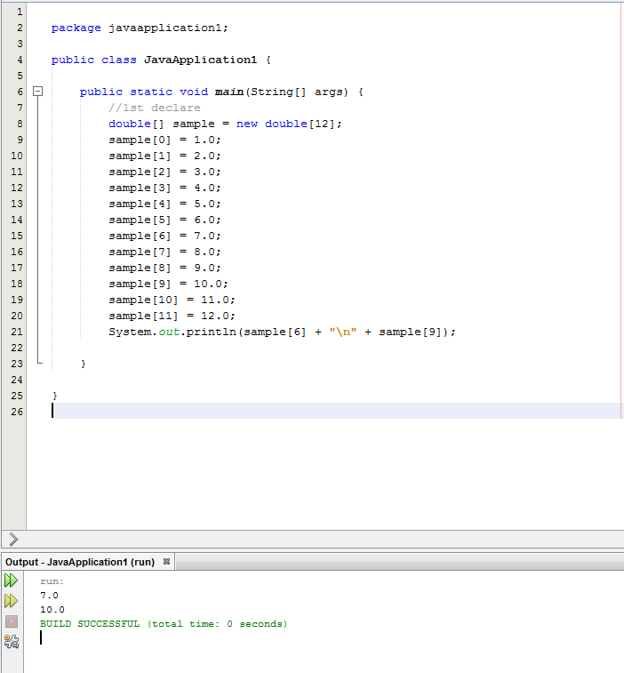

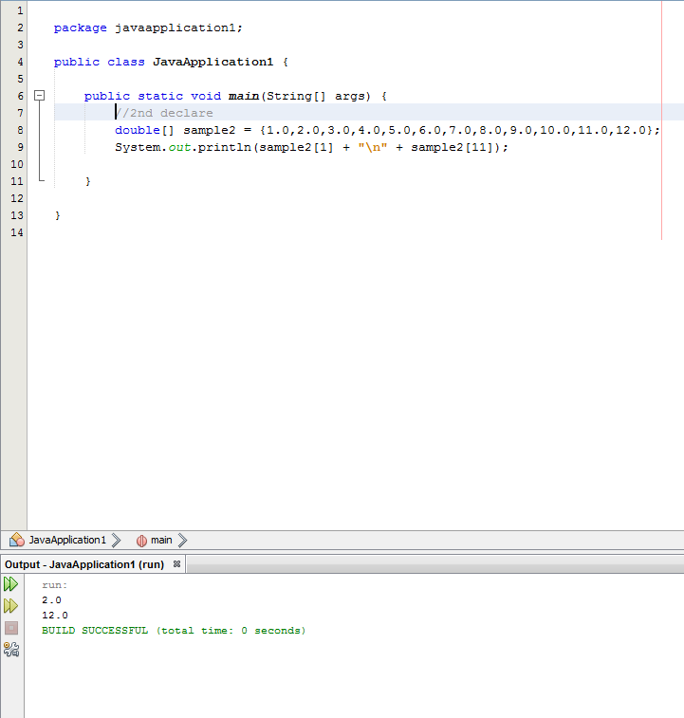

Pg. 201, Java Programming *A comprehensive Introduction*

Task 2- Page 201 #3:

Write a program that uses an array to find the Average o 10 double values.

Use any 10 double values you like.

Use a **for** loop to cycle through the array when summing the total for all 10 double values.

Attach Snipping photos of source code and output.

